Non-Licensable Work with Asbestos including Notifiable Non-Licensed Work (NNLW)
(Formerly known as Category B)

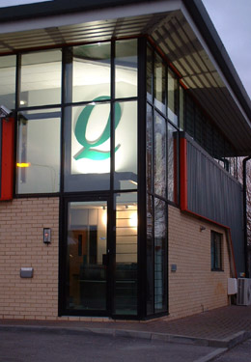
Course Syllabus

Morning session-Theory Module

- Asbestos Awareness- already undertaken recently
- Additional Legislation
- Use of Class H Vacuum (EM 4)
- Use of Wetting control measures (EM 5)
- Personal protective equipment (EM 6)
- Cleaning (EM 7)
- Decontamination (EM 8)
- Waste (EM 9)
- Certificate of handover (EM 10)
- Risk assessment and plans of work
- Emergency Procedures

Afternoon session Practical Elements

- Use of H class Vacuum
- Use of PPE and RPE
- Use of wetting techniques
- Bagging Waste
- Decontamination

Practical training will focus on 3 or 4 tasks from HSG210 as selected by client.
Assessment = (30 questions)
Delegate ratio
Theory Element – Maximum Tutor: Delegate ratio is 1:12
Practical Element-Maximum Tutor: Delegate ratio is 1:6

Please Note: This syllabus is for those who have undertaken asbestos awareness/refresher training recently.
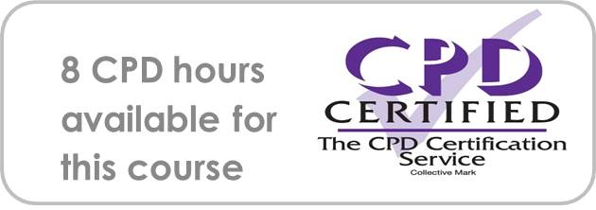
If you would like your Organisation’s standard asbestos procedures covered during the training session, please provide to Enquin beforehand.

