23 May 2017
Asbestos in Soils
The UK is short of housing and approximately 3 million homes need to be built by 2030. The use of brownfield sites for residential development is on the increase. Brownfield land has formerly been used for industrial or commercial purposes but is often now derelict or disused, and often contains asbestos in the soil.

Background
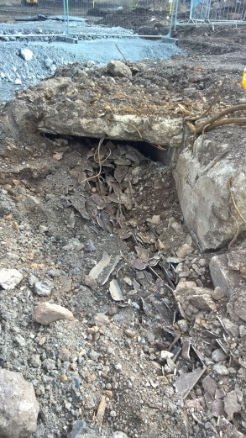
Asbestos in soils has been overlooked for many years by guidance, legislation and professionals, many of which thought damp soils meant no risk of fibre release. There was limited legislation and controls in place, which governed the use, spread and management of asbestos. Prior to 1996 when the Special Waste Regulations were introduced, licensable high risk asbestos was undoubtedly included into made ground from demolition of buildings.
Asbestos cement debris
But it isn’t just from demolition of buildings that asbestos containing materials (ACMs) have been included in the ground, other ways include; unauthorised or unregulated landfills, uncontrolled demolition of buildings with asbestos becoming incorporated into made ground and long forgotten ducts and buried structures containing asbestos being uncovered many years later.
Many Asbestos Containing Materials (ACMs) are friable and use cementitious products to bind or comprise the matrix, and this will deteriorate over time, such as Asbestos Insulating Board (AIB), lagging and insulations, leading to concentrated areas of free fibres in soils.
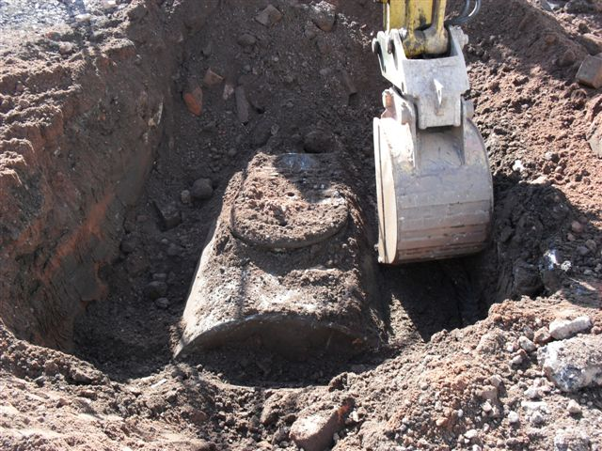
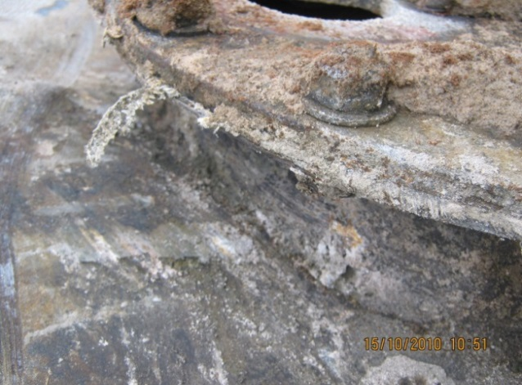
Exposed asbestos gasket

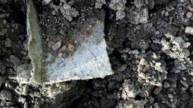
Where land contamination is suspected ‘The Model Procedures for the Management of Land Contamination’ (CLR 11) indicates that initial/preliminary assessments should be carried out as the first step in consideration of the risks associated with potentially contaminated land. Detailed guidance for preliminary investigations is set out in Investigation of Potentially Contaminated Sites – Code of Practice (BS10175). In all circumstances where work of any nature is to be undertaken at a site, regardless of the purpose, there is a need to assess the potential for human health exposure risks to occur to those who may be involved directly or indirectly with the investigation process. The principal legal drivers for this are the Control of Asbestos Regulations 2012 (CAR2012).
Degraded asbestos material
Uncovering asbestos containing materials (ACMs) during ground works is more common place than was at first realised. As awareness increases, so will the reported cases of asbestos being discovered through ground works. This in turn will lead to more cases where large-scale remediation will be required.

There is still varying attitudes towards the risk posed by asbestos in soils and the made ground. There are various training courses becoming available by several organisations to supplement the standard asbestos awareness training to specifically cover asbestos in soils, for ground workers, consultants and investigators.
Historic Guidance and Standards
Historically the guidance available was limited and had significant aspects missing, such as details on risk assessments. A brief summary is as follows:
ICRCL Guidance note 64/85 “Asbestos on Contaminated Sites” published in 1990, this document included:
- Site assessment procedure similar to other contaminants
- If obvious ACMs present, treat as contaminated
- If no obvious ACMs, test soil for free fibres (LOD <0.001%)
- But did not include any detail on risk assessment
Addison et al, IOM (1988) identified fibre concentrations of >0.001% may give rise to significant airborne fibre levels, which highlights drier soils with free fibres, can be significantly dangerous.
Davies et al, IOM, HSE Contract report 83/1996, developed and validated an analytical method to determine the amount of asbestos in soils and loose aggregates, with a Limit of Detection (LOD) of 0.001%, which is the current method used by UK labs.

The Standing Committee of Analysts Blue Book Method for the determination of asbestos in soil and associated materials has been amended and reviewed extensively by a working group and has been issued for wider consultation, review and comment, with a release date yet to be confirmed. Please find a link to the draft issue here.
Current Guidance
In recent years awareness of asbestos has increased and therefore the need for guidance. There are now quite a few guidance documents available which have been produced in recent years for asbestos in soils. Below is a summary on each of the guidance documents, providing links and costs if any are applicable.
- CL:AIRE (FREE Guidance)
CL:AIRE has published the Joint Industry Working Group Asbestos in Soil and Construction & Demolition (C&D) Materials guidance titled “Control of Asbestos Regulations 2012: Interpretation for Managing and Working with Asbestos in Soil and Construction & Demolition Materials: Industry Guidance (shortened name CAR-SOILTM)”.
This authoritative document has been prepared with the support of the Health and Safety Executive and presents the definitive explanation of how the legal requirements of the Control of Asbestos Regulations 2012 (CAR 2012 or the Regulations) have been interpreted to apply to work with asbestos contaminated soil and construction/demolition materials.
Appendix 2 provides good photographs of a range of not untypical examples of soil and C&D materials contaminated by ACMs.
A free download of the guidance document is available here.
- AGS Interim Guidance (Free Guidance)
In February 2013, “Interim Guidance: Site Investigation Asbestos Risk Assessment for the Protection of Site Investigation and Geotechnical Laboratory Personnel” was published. The AGS website states “There is existing HSE guidance that can be readily applied to the presence of asbestos in buildings and asbestos that is lying on the surface of the ground. In the absence of specific government advice in regard to asbestos contained in soils, this guidance is issued to AGS members so that they may be aware of their responsibilities and to offer a practical means of discharging their duties pending the publication of new guidance from HSE.”
The document can be downloaded here
- CIRIA (£65 - £100 cost)

“Asbestos in Soil and Made Ground: a Guide to Understanding and Managing Risks” (C733) guidance document was published by CIRIA in 2014, designed to provide contaminated land professionals with practical guidance on assessing asbestos risk from ground. The project also aimed to improve understanding of the dose-response relationship between exposure to asbestos fibres and mesothelioma. A link to the CIRIA website and guidance can be found here.
CIRIA (£40 - £80 cost)
“Asbestos in Soil and Made Ground Good Practice Site Guide (C765)” has also been produced by CIRIA which is designed to provide advice to all site workers who may come into contact with, or are required to manage, soils that have the potential to contain asbestos (eg groundworks/earthworks contractors, ground investigation contractors/supervisors, consultants, waste handlers). A link to the CIRIA website and guidance can be found here.
- HSE – HSG 248 Draft (Free Guidance)
The HSE’s revised New Draft Analyst Guide is available for public consultation so is liable to change and is not officially published to date, but is available to preview and download from the HSE website here.
Amongst other changes it includes sections on ‘Sampling and analysis of soils and made ground for the presence of asbestos’ and ‘Surveying and sampling for asbestos in soil and made ground’.
Choosing a Lab, Type of Analysis and checking accreditation.
There are several tests and sample types for assessing asbestos in soils which will need to be evaluated, to determine which is required for your site. A brief summary of the options and accreditation requirements is provided below:
- Soil or made ground with pieces of ACM (if removing pieces of ACM from soil samples and analysing these in accordance with HSG 248 then such analysis will be covered by standard UKAS bulk analysis accreditation.)
- Asbestos fibres in soil – qualitative analysis (yes/no)
- Asbestos fibres in soil – quantitative (%)
For a laboratory to provide analysis of ACMs it must be accredited by UKAS to ISO/IEC 17025. To assess the soils and provide concentrations of asbestos fibres in soils, the laboratory will have to demonstrate its competence to undertake such preparations to UKAS. Once this activity has been satisfactorily assessed “soil preparation and identification” shall be included on the laboratory’s schedule of accreditation. The resulting reports from this analysis shall state soil as the matrix but cannot report any quantification of

the asbestos content. Staff undertaking the analysis shall hold the BOHS P401 qualification (or Certificate of Competence-CoC) as a minimum.
Analysis to establish the quantification of the asbestos content again requires additional procedures, and therefore the laboratory shall demonstrate its competence to undertake such preparations to UKAS, which could be by way of an extension to scope. Once this activity has been satisfactorily assessed, “soil – preparation, identification and quantification” shall be included on the laboratory’s schedule of accreditation.
Always check your laboratory’s schedule of accreditation to ensure the appropriate level of accreditation is in place for the type of analysis you require.

