Course Syllabus

- Properties, risks and the effects on health of asbestos exposure
- Types, uses and likely occurrence of asbestos and ACM’s in buildings
- How to avoid the risks from asbestos
- Outline of Legislation relating to asbestos

Learning Objectives

On successful completion of this course, delegates will:

- Have an increased awareness of the nature and properties of asbestos and its effects on health, including the increased risk of lung cancer for asbestos workers who smoke;

- Be familiar with the types, uses and likely occurrences of asbestos in buildings and where appropriate items of machinery;

- Know how to avoid the risks from asbestos by understanding;

- Where to obtain information on asbestos in premises prior to commencing work;

- What to do if suspicious materials are found;

- How to use appropriate workplace precautions, including the risk assessment process, or seek advice on workplace precautions, in respect of the risks of asbestos;

- Undertake work activities in a safe manner and without risk to themselves or others.

- Have an awareness of the key aspects of the asbestos regulations and how they fit into the broader context of health and safety legislation.

- Understand the procedures to be followed when coming into unintentional contact with asbestos containing materials (ACM’s) and an understanding of the appropriate emergency arrangements.

Assessment = (15 questions)
Delegate ratio: Maximum Tutor: Delegate ratio is 1:15
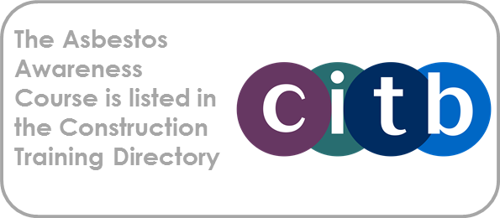
In-Company Training: If you would like your Organisation’s standard asbestos procedures covered during the training session, please provide to Enquin beforehand.

